Guru99 Bank
Test report
Version 1.3
13/06/2021

Prepared by
Alina Zhuravskaja
alinazhuravskaja@gmail.com

VERSION HISTORY
Date | Description | Author | Comments
25/10/2013 | Version 1 | Sam Patrick | Initial Draft
30/10/2013 | Version 1.1 | Sam Patrick | Added section 5.Change management process
5/11/2013 | Version 1.2 | Sam Patrick | Added section 3.7 Design constraints
15/11/2013 | Version 1.3 | Sam Patrick | Typos Fixed

Table of Contents
1.0 Introduction 4
1.1 Purpose 4
2.0 Test Summary 4
2.1 Smoke test 4
3.0 Test SHEDULE 4
4.0 dEFECTS 6
5.0 METRICS 8
6.0 conclusion 10

1.0 Introduction

1.1 Purpose
This Guru99 Bankе test report provides a summary of the results of test performed as outlined within this document.

2.0 Test Summary
The QA team was website “Guru99 Bank” (version 1.3) which aims to provide net banking facility to its customers. The testing was based on 72 test cases, which include functional and usability testing.
The purpose of testing was verified that all general features of the website are worked correctly

2.1 Smoke test
Test Owner: Alina Zhuravskaja
Test Date: 07/06/2021-11/06/2021
Test Results: Passed -43; Failed -28.

3.0 Testing Schedule
Name | Data | Actions
AlinaZ | 07/06/2021 | Design Test
AlinaZ | 08/06/2021-10/06/2021 | Testing
AlinaZ | 08/06/2021-10/06/2021 | Bag report
AlinaZ | 12/06/2021 | Test report

4.0 defects

4.1 statistic of defects
Status | Quantity | Priority
Status | Quantity | Highest | High | Medium | Low | Lowest
Open | 29 | 7 | 10 | 5 | 5 | 2

4.2 LIST OF NEW DEFECTS
Defect | Severity of Defect | Summary of Defect | Status
BP-1 | Major | Login page: the field "Password" doesn't have limit of the values when enter symbols | Open
BP-2 | Trivial | Home page: Logo is not correct show when user is logged to home page | Open
BP-3 | Trivial | Home page: 3 pictures are not correct located in the top center of the page | Open
BP-4 | Blocker | Home page: There aren't all modules in the main menu when user is logged to home page | Open
BP-5 | Minor | Home page: Welcome lettering "Welcome To Manager's Page of Guru99 Bank" is not correct and dynamic when user is logged to page | Open
BP-6 | Critical | New customer is not added when enter valid data | Open
BP-7 | Minor | New Customer: The error message is not correct when the field "Customer Name" enter with space before character | Open
BP-8 | Critical | New Customer: there isn't error message and page is loaded when the field "Address" left empty | Open
BP-9 | Critical | New Customer: there isn't error message and page is loaded when manager enter first character with space in the field"Address" | Open
BP-10 | Critical | New Customer: there isn't error message and page is loaded when manager enter special characters to "Address" | Open
BP-11 | Minor | New Customer: The error message is not correct when the field "City" enter with space before character | Open
BP-12 | Minor | New Customer: The error message is not correct when the field "State" enter with space before character | Open
BP-13 | Critical | New Customer: The page is loaded with new customer when manager enter first digits with space in "PIN" | Open
BP-14 | Critical | New Customer: The page is loaded with new customer when manager enter first number with space in "Telephone Number | Open
BP-15 | Critical | New Customer: The page is loaded with new customer when manager enter first number with space in "Email" | Open
BP-16 | Critical | New Customer: The page is loaded with new customer when manager enter email without domain part with 2 dot | Open
BP-17 | Critical | New Customer: The page is loaded with new customer when manager enter email with two "at" | Open
BP-18 | Critical | New Customer: The page is loaded with new customer when manager left the field "Date of Birth" empty | Open
BP-19 | Trivial | New Customer: Instead "Mobile Number" the field is called "Telephone Number" | Open
BP-20 | Major | Customized Statement Form is loaded when manager or customer enter special symbols to field "Amount Lower Limit" | Open
BP-21 | Minor | Customized Statement Form: There isn't error message when manager or customer enter special characters to field "Number of Transactions" | Open
BP-22 | Major | Customized Statement Form is loaded when manager or customer left the field "Number of Transaction " empty | Open
BP-23 | Critical | Customized Statement: The system doesn't display error message when manager or customer choose From Date is greater than To Date | Open
BP-24 | Trivial | New Account: If compare with mockups, "mandatory fields" should not be for all fields | Open
BP-25 | Minor | New account:There isn't error message when manager the field "Customer id" enter with special characters | Open
BP-26 | Minor | New account:There isn't error message when manager the field "Customer id" enter with characters | Open
BP-27 | Trivial | Mini Statement Page: When you compare with mockups, "mandatory field" should not be for field "Account No" | Open
BP-28 | Trivial | Log out: When user is logged out the name of message appears with mistakes | Open
BP-29 | Blocker | The button "Home" is loaded page error 404 in all modules | Open

5.0 Metrics

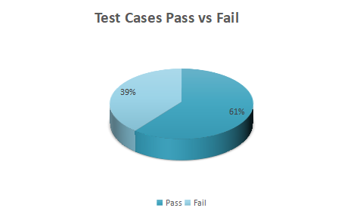

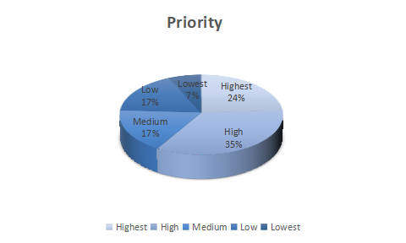

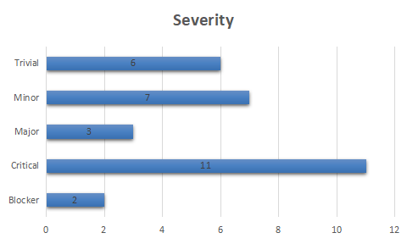
Defects distribution – module wise
 | Login page | Home Page | New customer | Customized Statement | New Account | Mini Statement | Log out | Total
Blocker |  | 2 |  |  |  |  |  | 2
Critical |  |  | 10 | 1 |  |  |  | 11
Major | 1 |  |  | 2 |  |  |  | 3
Minor |  | 1 | 3 | 1 | 2 |  |  | 7
Trivial |  | 2 | 1 |  | 1 | 1 | 1 | 6
Total | 1 | 5 | 14 | 4 | 3 | 1 | 1 | 29

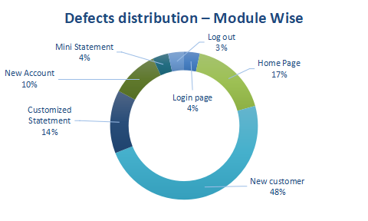
`

6.0 Conclusions
The testing has shown that the website is not ready for release testing and subsequent production operation. QA team had found 29 defects where 2 - blocker, 11 - critical . If the Dev team fixes these defects, it will be possible to perform re-test, regression testing by QA team. If the new build works properly the company will be able release testing for the new build.

